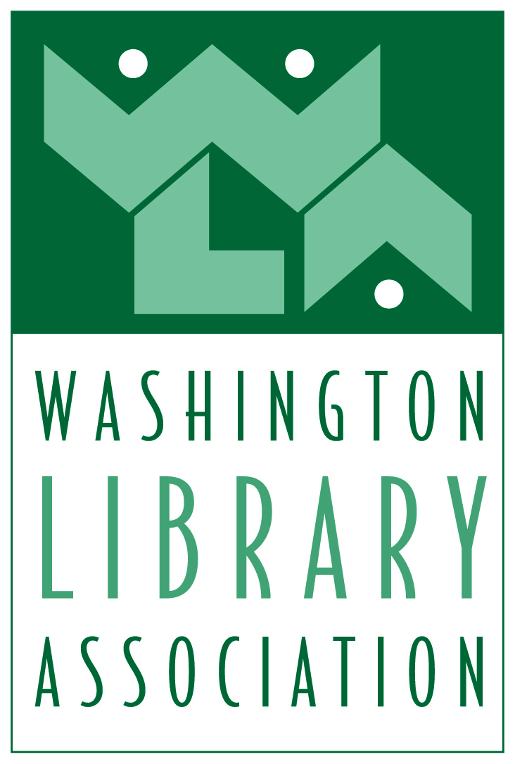
Board of Directors Meeting
July 15, 2014
Online Meeting via Blackboard Collaborate
MINUTES

PRESENT: Board Members – Nancy Ledeboer, Christine Peck, Phil Heikkinen, Brianna Hoffman, Darcy Brixey, Tim Mallory, Krista Ohrtman. Committee Chairs and Interest Group Representatives – Megan Dazey, Korissa Fitterer, Rob Roose, Jeanne Fondrie, Chris Skaugset, Diane Cowles, Susan Lee, Teresa Claypool Staff – Dana Murphy-Love, CAE, Kelsi Graffis.

CALL TO ORDER - The meeting was called to order at 1:05 pm.

Approval of Agenda – motion was made and seconded to approve the agenda. Motion carried.

Approval of Minutes – motion and second to approve the minutes of the April 30 board meeting with the correct spelling for Eliza Dresang. Motion carried.

President’s Report – Nancy Ledeboer reported on activities that she has been involved in since the beginning of her administration in April.
- All Committee Chairs have been appointed. She asked that board members contact her with the committees that they would like to be liaisons to.
- 2014 Strategic Plan Update – Nancy reviewed the work plan from the Strategic Planning Session. Committees will be using the work plan as their guide on projects for the upcoming year.
- Washington Information Literacy Proclamation – Rand Simmons had submitted this to the board for consideration. Motion and second to approve the proclamation. Motion carried.
- Management and Board Evaluation Results – Nancy reviewed the results noting that there were a couple of areas in the board results that she would be targeting for improvement in the upcoming year.
- Management Agreement with MCA – motion and second to approve the Management Agreement. Motion carried.

Executive Director’s Report – Dana Murphy-Love reported on the chapter activities/meetings that she was involved in at ALA in Las Vegas, noting that she facilitated a session on Member Engagement at the Chapter Leaders Forum.
- Code of Conduct and Conflict of Interest Statements – Dana noted that all board members should sign both statements and send them back to her via email or fax. These documents are to be signed annually by board members as they are recommended in the tax return questionnaire.

WLA Board of Directors Meeting
July 15, 2014 – Minutes Page 2

General Reports
- ALA Councilor Report – Christine reported on the issues from the ALA Annual Meeting including the Librarians Building Communities project, the Council Committee on Committees and that she had posted materials on the WLA Blog.

New Business
- One Book Program – Darcy Brixey has suggested that WLA create a One Book project for the coming year. This would be a book that all members would be asked to read if they want to participate. There could be book club meetings/events throughout the year, perhaps online. The Board agreed that this program sounded great. Darcy will work on specifics and send out to the board.
- 2014-2015 Budget – Phil Heikkinen presented the draft budget for 2014-2015, highlighted various areas where revenue and expenses had increased. Motion and second to approve the budget as submitted.

Next Meeting – September via Blackboard. Dana will send out a Doodle Poll to set the date.

There being no further business to come before the board, the meeting adjourned at 2:30pm.

